character specied by the argument char to stdout:

C. To take a single character ch as input, you can use scanf("%c", &ch); and prin("%c", ch) writes a

Q2) This challenge will help you to learn how to take a character, a string and a sentence as input in

OUTPUT:

Hello, World!

Sample Output 1

Print Hello, World! to stdout.

Output Format

You do not need to read any input in this challenge.

Input Format

or cout to print the string Hello, World! to stdout.

prinng the most famous compung phrase of all me! In the editor below, use either prin

This is a simple challenge to help you pracce prinng to stdout. We're starng out by

Q1) Problem Statement:

Week : 01-01

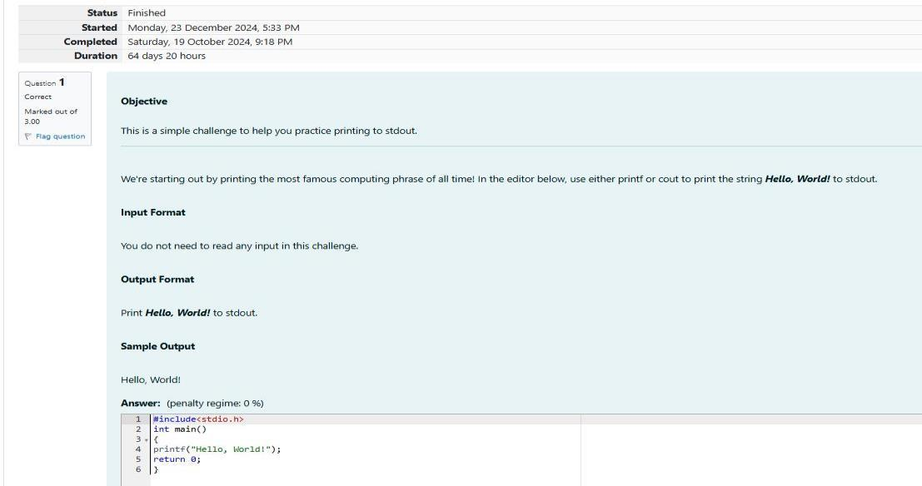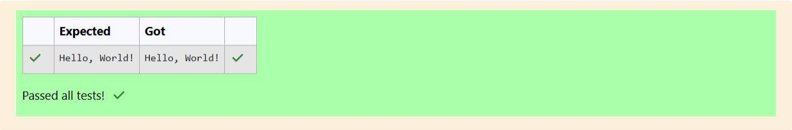

Q3) Problem Statement:

OUTPUT:

Programming using C

program

C

Sample Output 1

Programming using C

program

C

Sample Input 1

prin("%c", ch);

scanf("%c", &ch);

char ch;

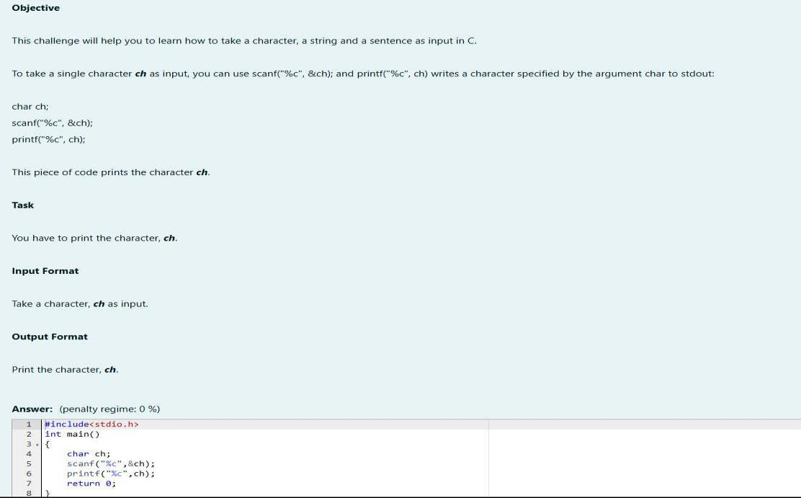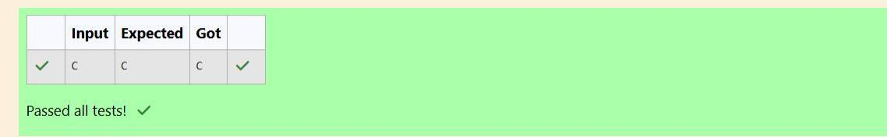

6.0 2.0

14 6

Sample Output

4.0 2.0

10 4

Sample Input

dierence of both oat (scaled to 1 decimal place) separated by a space on the second line.

Print the sum and dierence of both integers separated by a space on the rst line, and the sum and

Output Format

1 ≤ oat variables ≤ 10^4

Constraints: 1 ≤ integer variables ≤ 10^4

The second line contains two oang point numbers.

The rst line contains two integers.

Input Format

Print the sum and dierence of two oat variable rounded to one decimal place on a new line.

Print the sum and dierence of two int variable on a new line.

Use the + and - operator to perform the following operaons:

below) and inialize your 4 variables.

Read 2 lines of input from stdin (according to the sequence given in the 'Input Format' secon

Declare 4 variables: two of type int and two of type oat.

output their sum:

Your task is to take two numbers of int data type, two numbers of oat data type as input and

Task

a single line, the command is scanf("%d %d", &n, &m), where n and m are the two integers.

console and stores the given value in variable number.To input two integers separated by a space on

argument_list);. For ex: The scanf("%d", &number) statement reads integer number from the

The scanf() funcon reads the input data from the console. The syntax is scanf("format string",

respecvely.

then in the format string we have to write %d (integer), %c (character), %s (string), %f (oat)

argument_list);. In the funcon, if we are using an integer, character, string or oat as argument,

The prin() funcon prints the given statement to the console. The syntax is prin("format string",

types.

The fundamental data types in c are int, oat and char. Today, we're discussing int and oat data

OUTPUT:

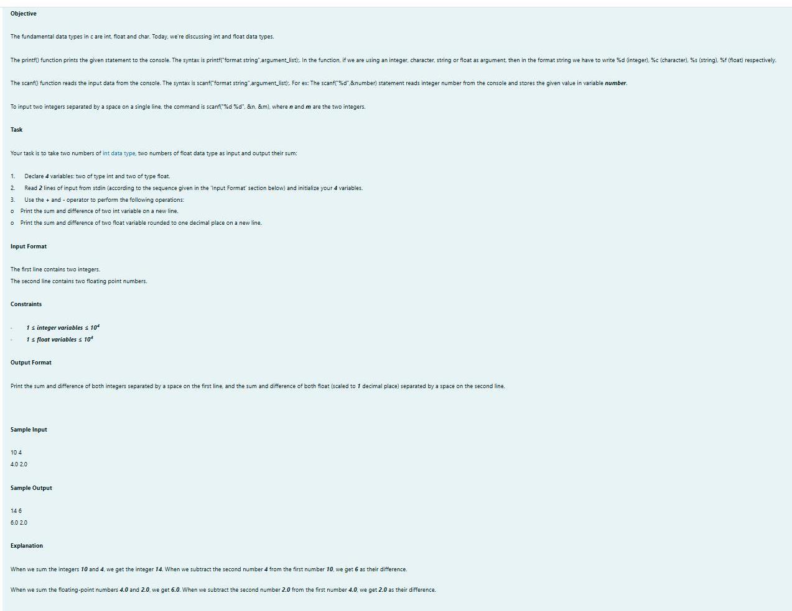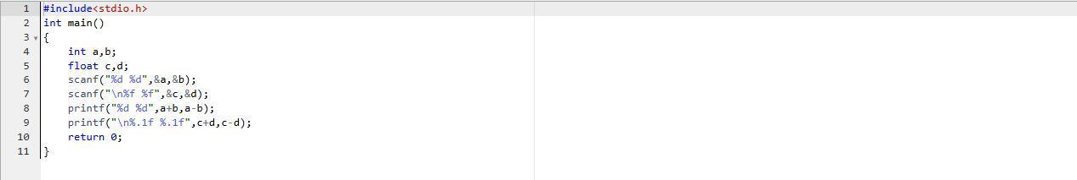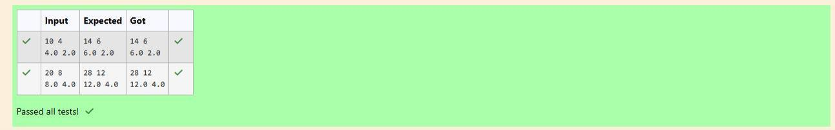

4

A

Sample Output 1:

3 4 6

A

Sample Input 1:

Marks for each student lie in the range 0 to 100 (both inclusive)

Constraints

mark.

First line of output prints the name of the student. Second line of the output prints the average

Output Format:

Line 2: Marks scored in the 3 tests separated by single space.

Line 1: Name (Single character)

Input Format:

to print the integer part of the average only and neglect the decimal part.

All the test marks are in integers and hence calculate the average in integer as well. That is, you need

menoned in the output format secon.

Now, you need to calculate the average of the given marks and print it along with the name as

of a student considering all the three marks have been given in integer format.

Write a program to input a name (as a single character) and marks of three tests as m1, m2, and m3

Q1) Problem Statement

Week:01-02

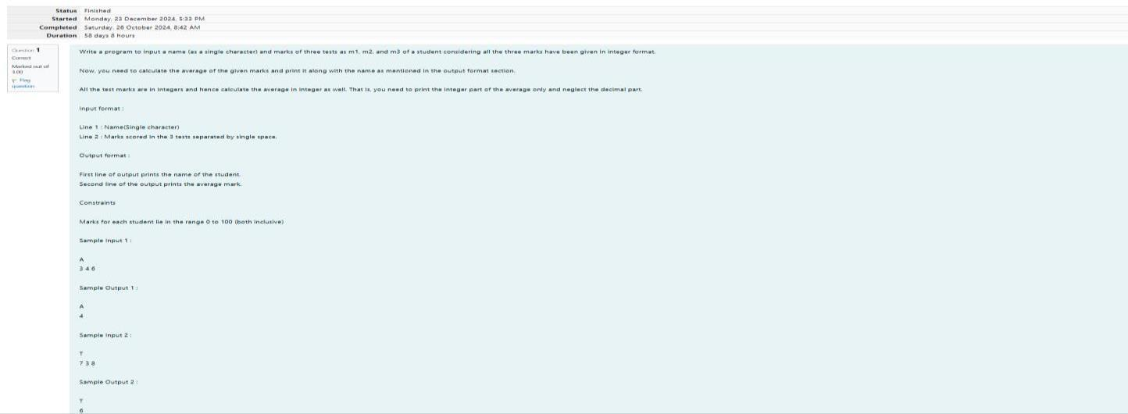

To print a data type, use the following syntax:

Prinng

For the moment, we can ignore the spacing between format speciers.

scanf("%c %lf", &ch, &d);

double d;

char ch;

C

For example, to read a character followed by a double:

scanf("format_specier", &val)

To read a data type, use the following syntax:

Reading

Double ("%lf"): 64 bit real value

Float ("%f"): 32 bit real value

Char ("%c"): Character type

Long ("%ld"): 64 bit integer

Int ("%d"): 32 Bit integer

Some C data types, their format speciers, and their most common bit widths are as follows:

Q2) Problem Statement:

OUTPUT:

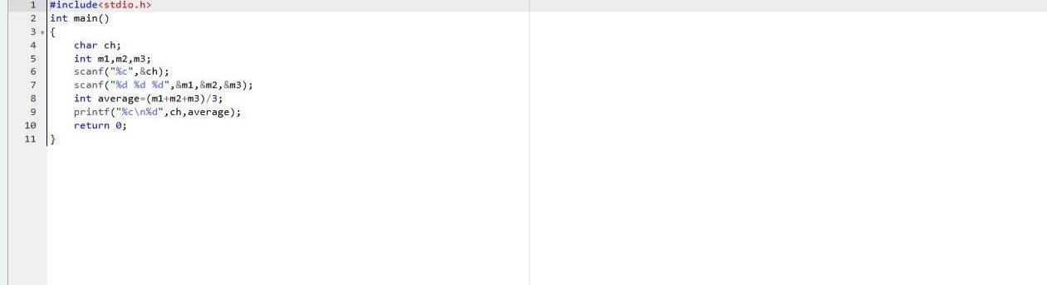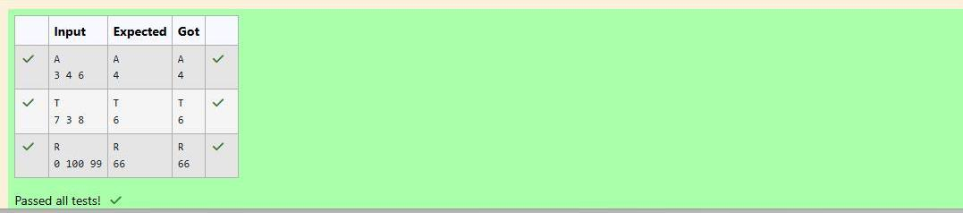

14049.304930000

334.230

a

12345678912345

3

Sample Output

14049.30493

334.23

a

12345678912345

3

Sample Input

point value should be correct up to 3 decimal places and the double to 9 decimal places.

Print each element on a new line in the same order it was received as input. Note that the oang-

Output Format

respecvely.

Input consists of the following space-separated values: int, long, char, oat, and double,

Input Format

numbers as input and prinng a million lines, it is faster to use scanf and prin.

Note: You can also use cin and cout instead of scanf and prin; however, if you are taking a million

prin("%c %lf", ch, d);

double d = 234.432;

char ch = 'd';

C

For example, to print a character followed by a double:

prin("format_specier", val)

DF

69

Sample Output 1:

E

Sample Input 1:

character of the input character

Output Format: First line prints the ascii value, second line prints the previous character and next

Input Format: Reads the character

Write a program to print the ASCII value and the two adjacent characters of the given character.

Q3) Problem Statement:

OUTPUT:

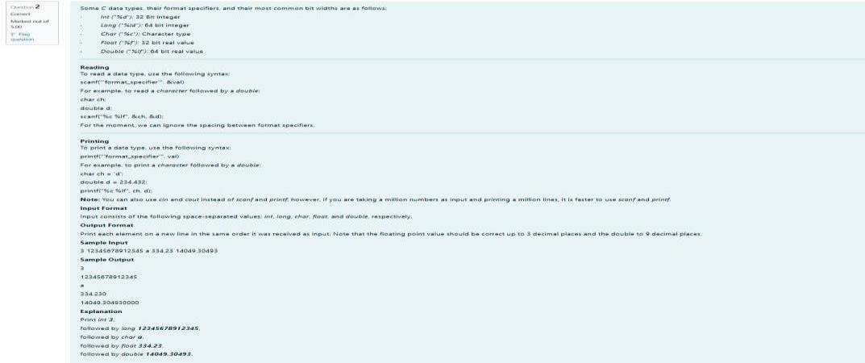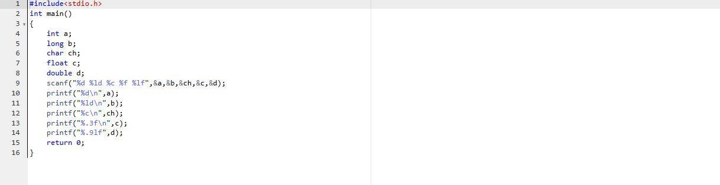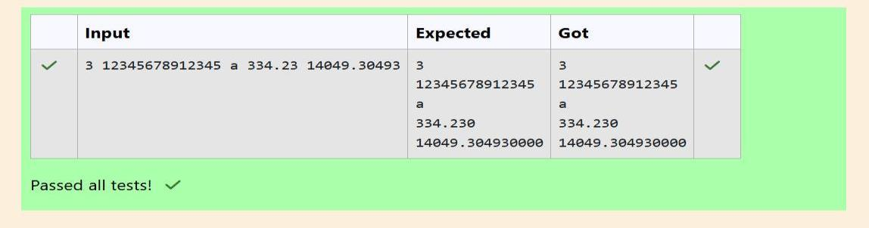

OUTPUT:

